PROJECT TITLE: Vibrating Coin

Aim:
To demonstrate the expansion of air when heated.

Materials Required:
1. Coin
2. Bottle
Procedure:
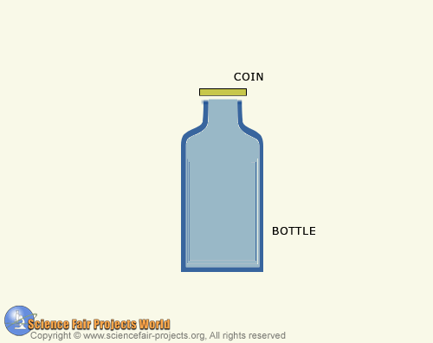

Place an empty bottle in a refrigerator to cool it. When the bottle is cold remove it and put a coin on the opening as shown. Then dip your finger in water and place a few drops around the edge of the coin to seal the opening. Then place both your hands around the bottle, holding it firmly for about fifteen seconds. The coin will start to click up and down. Let it vibrate for a while, then remove your hands. The coin goes right on vibrating ! This shows the illustration of how air expands when heated. The cold air inside the bottle is warmed by the heat from your hands and the expanding air escapes around the rim of the coin causing it to vibrate.

