PROJECT TITLE: Pascals Law

Aim: To demonstrate the Pascal's Law.

Materials Required:
1. Matchsticks
2. Bottle
3. Rubber balloon
Procedure:
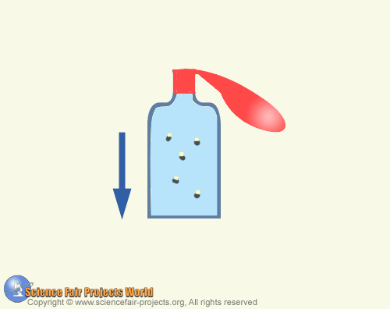

The pressure applied to a confined liquid is transmitted equally to all parts of the liquid according to Pascal's law. This can be shown with an empty bottle, a few matchsticks and a balloon. Cut off the heads of the matches and then drop the heads into the bottle and fill the bottle to the brim with water and cover the mouth of the balloon tightly over the bottle's opening. The match heads will float on top of the water but when the finger pressed on the balloon diaphragm they will sink slowly to the bottom. When the finger is lifted, and the heads float up again. This is because pressure is transmitted through the water, forcing a small quantity of water to penetrate the edge of each match head. This adds enough weight to the match head to make it sink and when the finger is removed, there is enough air pressure inside the heads to force out the water and make the match heads rise.

