PROJECT TITLE: Lift an Ice Cube

Aim:
To lift an ice cube from a glass of water using a string.

Materials Required:
1. Ice cubes
2. Glass of water
3. String
4. Salt shaker
Procedure:
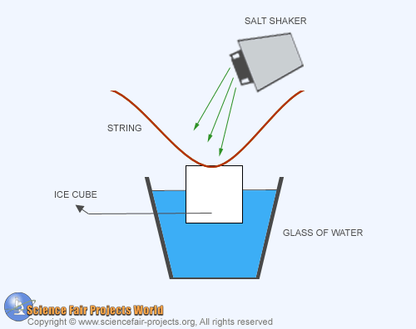

In a glass of water an ice cube is floating. A piece of string a few inches long is provided. You have to lift the ice-cube from the glass of water with the string without touching the ice with your hand. Place the string across the ice-cube floating in the glass, as shown. Then sprinkle some salt on top of the ice-cube from the shaker. The ice surrounding the string will start to melt and it will extract heat from the surrounding water which will refreeze around the string. Lift the string after a minute or two. The cube will adhere tightly to the string and you will be able to lift the ice-cube easily.

