PROJECT TITLE:
Inertia of Egg

Aim:
To demonstrate the Inertia of an Egg.

Materials Required:
1. Raw & boiled eggs
2. Glass plate
Procedure:
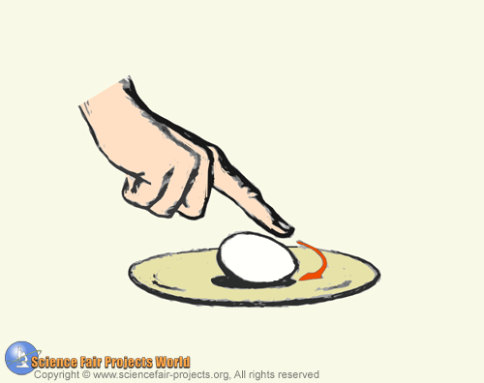

A dozen eggs are placed on a glass plate and one of them eggs is hard-boiled while the rest are raw. How can you find the hard-boiled egg without cracking the shell ? By utilizing the laws of inertia. Try to spin each egg on the plate and the only egg that will spin readily is the hard-boiled one. With a raw egg, the inertia of its liquid inside the egg exerts a drag effect that stops the spin.

