PROJECT TITLE:
Floating Ball

Aim:
To demonstrate the principle of air pressure.

Materials Required:
1. Plastic straw
2. Table-tennis ball
Procedure:
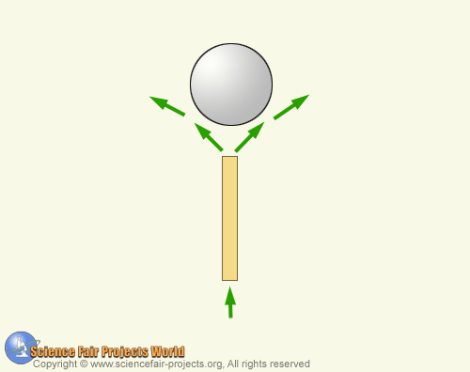

From the end of a plastic straw cut a 10 cm piece . Put one end of the straw in your mouth, tip back your head, and hold a table-tennis ball a few inches above the other end of the straw. Then blow as air hard as you can through the straw, simultaneously releasing the ball. The ball remains suspended in mid-air. The harder you blow, the higher it floats above the straw. The reason is that when air is in rapid motion, its pressure is lowered and the ball is actually imprisoned by the column of upward rushing air. As soon as it moves a bit to one side, the greater pressure outside the air stream forces the ball back into it again.

