PROJECT TITLE:
Egg in Bottle

Aim:
To put an egg in a bottle using air pressure.

Materials Required:
1. Hard-boiled egg
2. Bottle
3. Matches
Procedure:
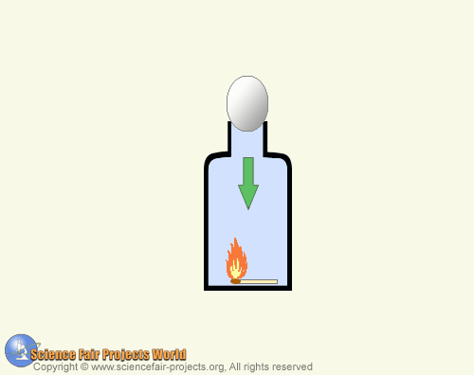

To demonstrate the effect of air pressure by putting a hard-boiled egg into a bottle and getting it out intact. Remove the shell of the hard-boiled egg. Drop a burning match into the bottle just before you put the egg on the mouth. The flame burns up the oxygen, thus creating a vacuum that sucks the egg into the bottle. Then turn the bottle upside down so the egg falls into the neck and blow air into the inverted bottle and the egg will pop out.

