PROJECT TITLE:
Double color flower

Aim:
To create a double color flower.

Materials Required:
1. White flower
2. Glass tumbler

Procedure:
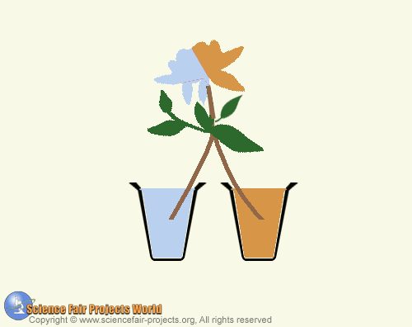

Fill two glasses with water and color the water in one glass red by using a dye. Then split the stem of a white flower and place half the stem in one glass, the other half in the other glass, as shown. After a few hours one side of the flower has turned to another color. This is because of capillary action carries water from the soil up through the roots of plants and trees, through the trunk or stem, and into the flowers and leaves. The liquid rises through sap tubes that produce the required capillary force.

