PROJECT TITLE:
Create Smoke Rings

Aim:
To create Smoke Rings.

Materials Required:
1. Cardboard box
Procedure:
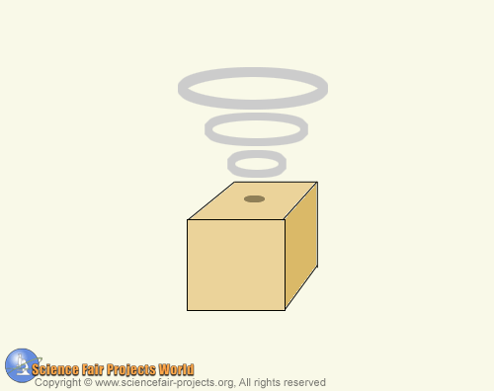

Take a cardboard box that is shaped like a cube. Cut a small round hole in the centre of one end and blow a puff of smoke into the box. Then gently tap the side of the box and a perfect smoke ring will rise from the opening. The experiment should be performed in a room free of air currents. When the box is tapped repeatedly a series of smoke rings will emerge and expand.

