PROJECT TITLE: Capillary Action

Aim:
To demonstrate capillary action of cloth.

Materials Required:
1. Cotton cloth
2. Glass cups
Procedure:
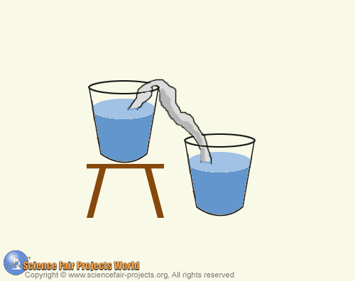

Take a small piece of cotton cloth, dip it in water and wring it out. Then twist it like a rope and place it over the rims of two glass cups as shown. Ensure that the cotton cloth touches the bottom of the higher glass, but hangs only a short distance below the rim of the lower one. Then fill the top glass with water and wait 24 hours. All the water would move to the lower glass. The water is drawn through the cloth by capillary action which occurs in porous materials.

