PROJECT TITLE: Anti-Gravity Machine

Aim:
To make an Anti-Gravity Machine

Materials Required:
1. Two plastic funnels
2. Cardboard
3. Adhesive cement
Procedure:
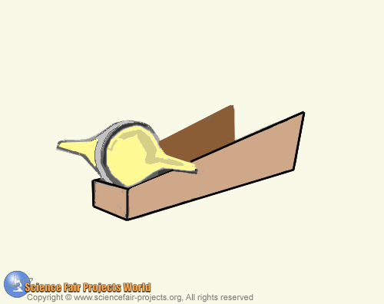

To make an Anti-Gravity Machine that seems to work against gravity. When the machine placed at the bottom of a sloping track, it appears to run uphill against gravity. The machine is a double cone, easily made from two plastic funnels. Use adhesive cement to stick their rims together. The sloping track is cut from cardboard, which has to be adjusted to get the slope just right, since the gradient will depend on the size of the funnels. Place the track so the two sides are about an inch apart at the lower end, with a width at the other end equal to the length of the double funnels. When the funnels are placed at the bottom of this track, it rolls to the top. This is because as the funnels appear to move up, the increasing width of the track lowers the funnels so that its centre of gravity actually becomes lower.

